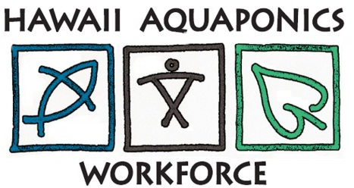

Observation Revisited Quiz
- What's the value of observation skills?

- Why observe closely and describe in detail?

- What happens when you do?

- What happens when you don't?

- What you are looking for?

6. Why is it important to take observation seriously?

7. What is important about reviewing of what others saw the previous week?

