Aquaponics: Fish Health #9

Name:___________________________
Date:___________________________

1. Fill in the Blank: Fish Anatomy

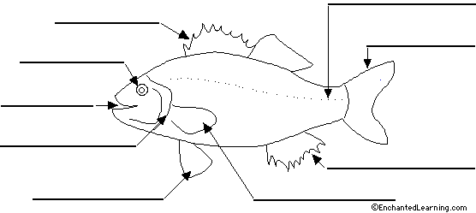
2. Select one of the 9 body systems and explain what the system does and what about this system is unique to fish (differences between fish and mammals).

