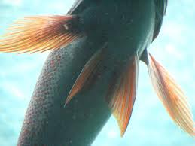
Factsheet
Let’s Learn About Fins
Read the information below to learn about the different types of fins. The second page contains a fish model that can be used. Cut the fish and fins out of the second page.

- Caudal fin: Used for giving a fish momentum during movement. Tilapias have a homocercal caudal fin which means vertebrae do not extend into a lobe and the fin is more or less symmetrical.

- Dorsal fin: The dorsal fin serves to protect the fish against rolling and assists in sudden turns and stops. (Hint: think about what dorsal means in relation to location of this fin on the fish body). The front part of the dorsal fin of tilapia has spines.

- Anal fin: This fin is used to stabilize the fish while swimming (Hint: the name of this fin helps give away its location).

- Pelvic fin: The pelvic fin assists the fish in going up or down through the water, turning sharply, and stopping quickly.

- Pectoral fin: Fish use these fins for maneuvering.

Now, take out your fish model. Using the above information label the five fins with the proper name and place them where they will go on the fish’s body. Do the best you can, use a pencil in case corrections need to be made. When everyone has completed filling in the blanks on their model’s 5 fins and has put the fish together we will go over the model together and discuss why each student labeled the fin the way they did and why they put that fin at a specific location on the model.

