Snails in Aquaponics Factsheet
Introduction
Introduction of unwanted species into a system can wreak havoc. The snails mentioned below (excluding apple snails) are hermaphrodites and breed rapidly, allowing them to become a nuisance very quickly. This factsheet will provide information on identification, negative impacts, prevention and treatment of snails in aquaponics.

Identification
There are three species of aquatic pest snails that are most common to aquaponic systems. These are the ramshorn snails (Planorbisspp.), tadpole/pond snails (Physa and Physella spp.) and turret/Malayan livebearing snails (Melanoides tuberculata) (Monks 2012). In Hawaii, another important snail to watch for is the apple snail (Pomacea canaliculata, Pomacea bridgesi, Pomacea paludosa, and Pila conica). These snails exist in tropical and subtropical areas.

Snail | Ramshorn | Tadpole/pond | Turret/Malayan | Apple Snail
Image | 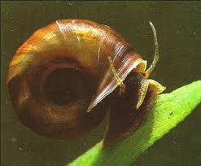 | 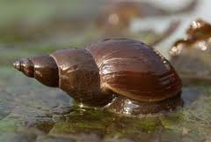 | 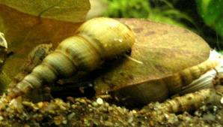 | 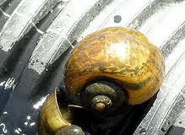
Description | Less than a quarter-inch across with a flat, spiral shell (Monks 2012) | Up to a half-inch long with a bulbous, translucent-brown shell (Monks 2012) | Up to one inch long with a conical shell (Monks 2012) | Can reach the size of an apple but stay below the size of a golf ball in Hawaii with a rounded yellowish to dark brown shell (HIS 2012)
Extra information | They exist in two different colors: black and red; the red lack the pigment melanin (Wikipedia 2012) | Eggs are laid in jelly-like clumps that are very distinctive (Monks 2012) | Sometimes active during the day but mostly nocturnal; also like to burrow through sand (Monks 2012) | The species Pomacea canaliculata was first reported on Maui in 1989 and Pila conica was reported in Hawaii in 1966 (HIS 2012)

Pathogens/Food Safety

Snails can carry and transmit rat lungworm (Angiostrongylus cantonensis) that will cause fever or even death in extreme cases when improperly cooked and eaten. Snails are also known to be a vector for blood flukes (Schistosoma spp.) and an intestinal fluke (Echinostoma ilocanum). These can be transmitted to fish and humans. Throw away any product that has snails, slugs or their slime on it as it could have come in contact with the rat lungworm pathogen.

Negative effects on system
- Snails consume nitrifying bacteria which results in higher concentrations of ammonia and nitrite
- Introduction of pathogens
- Some varieties of ramshorn snails particularly enjoy eating the leaves of stem plants
- Apple snails chew holes in taro plants (and eat young taro shoots) allowing bacteria and other pathogens to enter. Damage either kills the plant or drastically reduces crop quality and yield. They also damage other water-based crops such as watercress, water chestnut, azolla, water hyacinth, water spinach; economic loss due to apple snails is significant, but comprehensive studies have not yet been conducted.
Prevention
There are multiple ways snails may be introduced into an aquaponics system. Snails can survive and remain intact after being ingested by birds so a means of introduction into systems can happen via bird feces. Birds introduced snails into the UVI (University of the Virgin Islands) system. Therefore controlled environment or another means of keeping birds away from the system is a good preventative measure.
Snails are commonly introduced into systems via plants. Permanganate solution at up to 10 mg/l can be used to remove snails and snail eggs from plants before they are a problem. A 10 minute bath in a solution of 20 parts water to 1 part chlorine bleach followed by soaking in water and dechlorinating agent mixture has been suggested for stronger plants. Fragile plants can be treated with a more gentle solution of 5-10 tablespoons of alum to 1 gallon of water for 2–3 days. Addition of snail poisons to plants placed in a quarantine tank (not connected to the system) may be a safer alternative; soak plants well afterwards to ensure all snail poisons have been washed off before placing them into the system. Other preventative measures can be not

bringing plants in from an outside source; using plants you have raised yourself allows you to know if they come from and lowers the risk of introduction of unwanted pests.
Less frequently snails enter the system via water that new fish arrive in. Preventative measure for this introduction is to keep shipping water separate from system water by acclimating new livestock by means of some sort of “drip method” process. Another preventative measure for this is sourcing your fish from a hatchery that has BAP (Best Aquaculture Practices) in place and/or is a bio-secure facility.
A manual method of preventing snails is by setting traps around the system to discourage the snails from getting near the system area. This can be done by baiting snails into some type of fabricated container (homemade or purchased) with lettuce that has been run under hot water and left over night, cucumber slices, or food pellets. Once captured, snails can be crushed to effectively limit the population in the area.

Treatment
There are many treatments for snails but only a couple that are viable for aquaponics.

Chemical
Copper and potassium permanganate are the two classic molluscicides that should NOT be used due to the toxicity of both to fish and shrimps; potassium permanganate is also toxic to aquatic plants and filter bacteria. Another down side of these treatments is that even if the snails are the only animals to die having them decay in the system will reduce oxygen and increase ammonia. Consider it a rule that molluscicides will do more harm than good.

Biological
If infestation is minimal and eggs have not yet been laid control can be done by hand-picking the snails. When the infestation is past the minimal stage hydroponics tanks can be stocked with fish species that consume snails that will control the snail populations. Red ear sunfish fingerlings (Lepomis microlophus) were introduced into the UVI system but other species can be used. Carp and tilapia will eat young snails, but not adults.

