Seed Germination & Planting Guidelines
Instructions: After setting up your grow tank and fish tank using the SOPs, you will be ready to begin the planting process. First, make sure that you have healthy fish stocked, that the media/biofilter has established beneficial bacteria and that the water quality is at an acceptable level for plant growth. Please review these guidelines to proceed with your planting your grow bed.
Quick Guideline Summary: Seed absorbs water, growth begins with cell enlargement, seed coat breaks, radical root emerges, cotyledon emerge, light is not required, foliage leaves emerge
- Germination Requirements: A seed needs moisture (water) and warmth/warm temperatures (heat from the sun or light source) for a seedling to emerge. 75-80F is ideal. Sunlight is not necessarily required but it does play a role in the emergence process in the form of temperature and water evaporation rates, which could affect your seeds’ moisture level. During the first few days of seed germination, prior to the radical root emerging, light is not required. After that time, light must be provided.

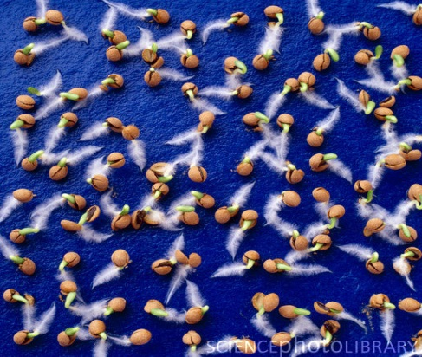
- Germination Success: Proper moisture and temperature levels must always be optimal for highest percentage of germination success. If these two factors are not maintained, germination may be delayed, stunted or not happen at all. While direct seeding, seeds must be grown in a media that can retain a slightly moist, slightly dry environment. As the seed absorbs water, it begins the growing process. Light is not yet necessary during the first phase of germination. Too much light during this period can often be the reason why a seed loses its ability to crack its seed, causing it to dry out and die. Consequently, too much water and the seed will be too supersaturated to emerge, causing the seed to “melt.”

- Direct Seeding Propagation: Seeding inside the grow bed as a method of propagation helps to ensure there is no transplant stress or shock. It is important to moisten the growing medium before planting. Over-seed by 25-50% in order to maintain your crop rotation status quo. Be sure to thin out the seedlings a week or two into growth cycle.

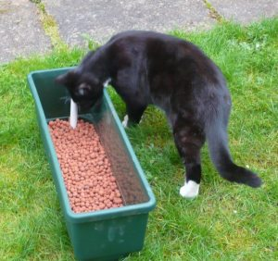
- Proper Care After Direct Seeding [Before Emergence Process Begins]: Seeds must be kept moist and given consistently warm temperatures for seeds to germinate correctly. This must be checked and maintained daily.

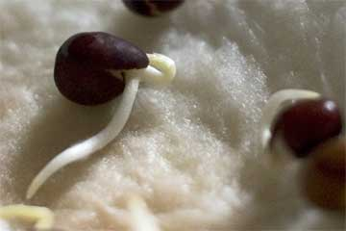
- Seedling Emergence: Water is the main component to control germination. Once the seed coat is cracked open from water absorption, the radical root emerges. At this point, you have a seedling, rather than seed, which requires water, nutrients, light and warmth to grow.

- Seed into Seedling: Once the seed coat breaks out and the radical root emerges, the seedling will need to draw moisture and nutrition from the media surrounding it. Several days after the radical root has emerged the shoot begins to grow. In the presence of light the seed leaves called cotyledons open. The opening of the first foliage leaves follows.

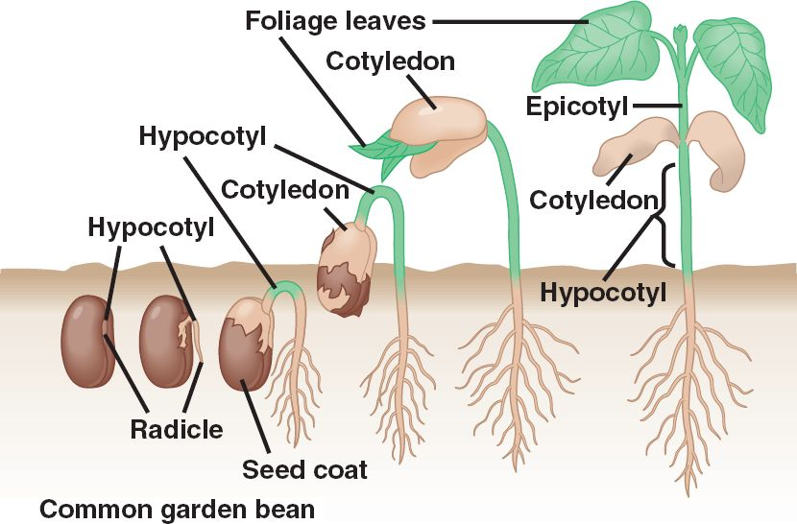

- Light: If proper light is not provided, a plant will grow tall and spindly as it searches for light. This is often referred to as “stretching.” Young plants will quickly do this if sufficient light is not available. If artificial light is necessary, set a timer that turns the light on for 16 hours and off for 8 hours each day. Do not leave the light on all the time. Plants need darkness as part of their daily cycle.

- Temperature: Providing the ideal temperature for your seeds will encourage quick germination. Each crop has a specific optimal temperature that can be achieved with a germination heating pad or other resources for temperature control.

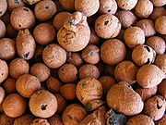
- Humidity and Water Content: The higher the relative humidity, the greater the absorption of water by the seed. Ideally, relative humidity should be around 70-80% in the air and 100% around the seed.

- Stocking Rate and Seed Selection: Picking the right seed to grow can depend on the amount of fish you have in your fish tank (stocking rate).

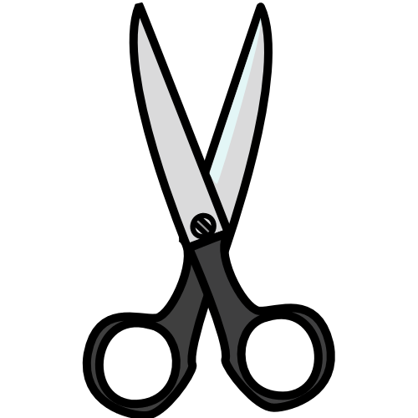
- Selecting the Strongest Seedlings: After 1-2 weeks, begin to select the healthiest seedlings to grow into your main crop. If a seedling appears weak, cut off the top. Note: Do not pull the plant out. Using scissors will ensure the healthy plant’s roots will not be disturbed.
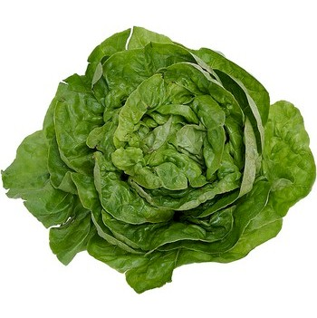

- Leafy Crop Selections: Lettuce grows best in a pH of 6.0-7.0 & 60-80F; Basil 5.5-6.5 & 75-80F; Watercress 6.5-7.0 & 65-75F.

