Behavioral Observations Reference
Area: | Zone:
Regional location of fish  A or B (circle one)  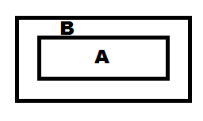Top View of Fish Tank | Depth of fish  Circle one  Upper Zone  Intermediate Zone  Lower Zone  Front View of Aquaria
Visible or Secluded: | Appetite/Feeding:
Is the fish actively swimming in open view or does it seem to be seeking refuge by an object in the aquaria (pump/filter)? | Is the fish eating? Is the fish eating more than other fish in the tank? What is the fish eating?
Social or Isolated: | Body Condition:
Is the fish neighboring other fish? Description and Identification of neighboring fish? Number of neighboring fish? | Are any scales missing? Are the fins intact with no marks?
Swimming or Immobile: | Comments:
Is the fish sitting stationary in the tank or is it actively moving throughout the tank?

Rate of Respiration
Count how many times the fish opens and closes its operculum in 15 seconds.
For example:
Respiration rate = number of breaths in one minute
# of breaths in 15 seconds x 4 = Respiration rate
30 x 4 = 120

High respiration rate can result from
• Rapid movement
• Food was recently consumed
• Low dissolved oxygen

