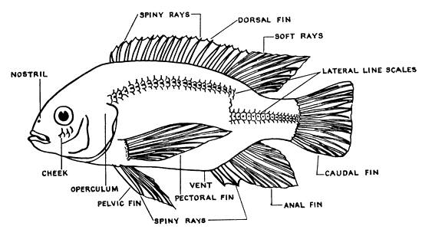**External Fish Anatomy Diagram**

**MOUTH**