What's the difference between a bacterial infection and a viral infection?
Answers from James M. Steckelberg, M.D.
As you might think, bacterial infections are caused by bacteria and viral infections are caused by viruses. Infections caused by bacteria include strep throat, tuberculosis and urinary tract infections. Diseases that result from viruses include chickenpox, AIDS and the common cold.
Bacteria are single-celled microorganisms that thrive in many different types of environments. Some varieties live in extremes of cold or heat, while others make their home in people's intestines, where they help digest food. Most bacteria cause no harm to people.
Viruses are even smaller than bacteria and require living hosts — such as people, plants or animals — to multiply. Otherwise, they can't survive. When a virus enters your body, it invades some of your cells and takes over the cell machinery, redirecting it to produce the virus.
Perhaps the most important distinction between bacteria and viruses is that antibiotic drugs usually kill bacteria, but they aren't effective against viruses. In some cases, it may be difficult to determine whether a bacterium or a virus is causing your symptoms. Many ailments — such as pneumonia, meningitis and diarrhea — can be caused by either type of microbe.
Inappropriate use of antibiotics has helped create strains of bacterial disease that are resistant to treatment with different types of antibiotic medications.

Steps
- 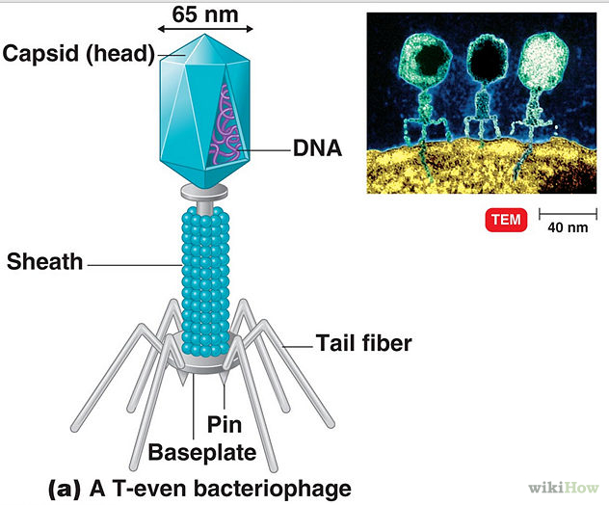
1
Look at the structure of bacteria and viruses. A virus isn't a cell and doesn't have any cellular parts. A virus has no internal cellular structure, no cell wall, or cell membrane. Viruses consist only of a protein coat that holds a coiled string of nucleic acid.
  - Bacteria, on the other hand, are singled-celled (unicellular) organisms. Bacteria are prokaryotic cells meaning that they do not have a cell nucleus. Unlike other cells, bacteria do not have vacuoles, Golgi apparatus, Endoplasmic reticula, or other organelles inside the cells. Bacteria consist of ribosomes, nucleoid(Strand of DNA), a cell wall, cytoplasm, and a flagella.
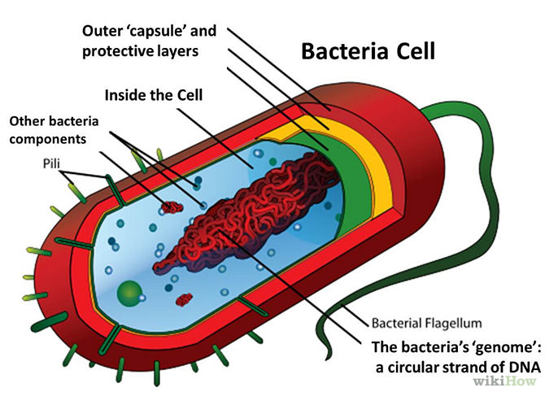
Ad
- 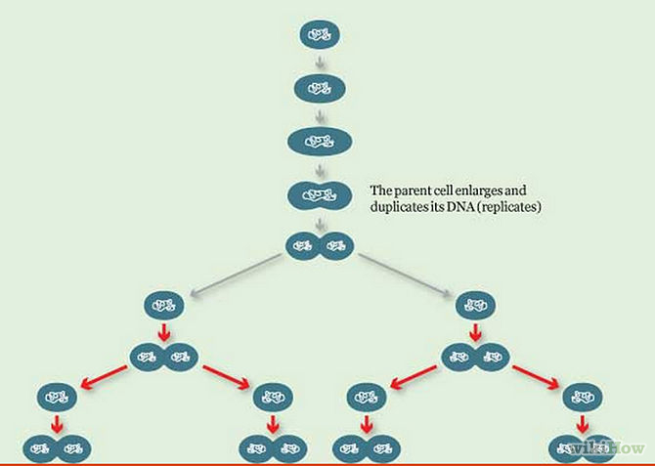
2
Know how they multiply. Bacteria and viruses multiply in very different ways. Bacteria are single-celled organisms and reproduce asexually, just like other cells. Asexual reproduction means that they only need themselves to reproduce and they reproduce by splitting into two cells and making an exact copy of themselves.Bacteria use binary fission to reproduce, another form of asexual reproduction. Viruses do not grow through cell division because they are acellular (Meaning "No Cells"), so they use a very different method of multiplying.
  - Viruses rely on other cells to multiply; depending on what shape the virus is, a certain cell will take the virus in and start making copies of the virus. When the viruses are ready to "live" outside the cell, they will break through the cell and finds other cells to repeat the multiplication process.
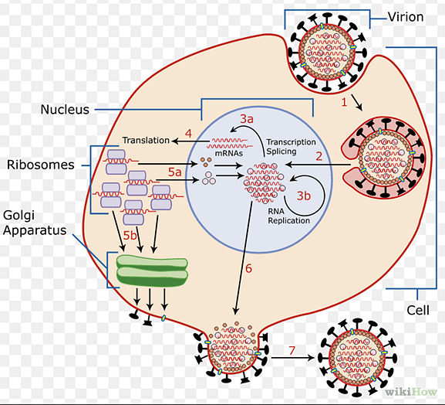
- 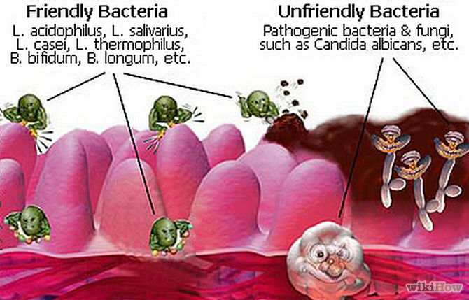
3
Consider what they do in the body. Viruses are considered parasites because they cannot "survive" without a living cell. Viruses only have one purpose or goal: to multiply. Viruses don't do anything good for the organism host. Bacteria, on the other hand, can do bad things for the body, like cause disease, and they can do good things for the body, like help make vitamins, depending on what type of bacteria they are. We couldn't even survive if we didn't have certain types of bacteria in our bodies! Pathogenic bacteria are the bacteria that cause infectious diseases. Examples of Pathogenic bacteria are Mycobacterium tuberculosis, Streptococcus, Salmonella. Human bacterial flora are bacteria that constantly live in the human body and do good things for our body. A good example of good bacteria are the gut flora. Gut flora is a term for the many bacteria living in our digestive tract and that perform a number of useful functions.
4
Look at how we get rid of them or the diseases they cause. A disease caused by bacteria and a disease caused by a virus are two very different things. In order to get rid of an infectious disease, one must take antibiotics to kill off the bacteria and to cure the infectious disease. However, you cannot cure a disease caused by a virus. There really isn't any medicine you can take to get rid of a virus without damaging the host's cells also. You can take medicine to make the symptoms of a disease caused by a virus more bearable, like cough medicine for example. Cough medicine doesn't make the virus go away, it only makes the symptoms go away or more bearable. To make a virus go away, you have to rely on your immune system to fight off the virus. You can also get vaccinations to help prevent yourself from suffering the effects of a virus.

Bacterial and Viral Infections
Bacterial and viral infections have many things in common. Both types of infections are caused by microbes -- bacteria and viruses, respectively -- and spread by things such as:
- Coughing and sneezing.
- Contact with infected people, especially through kissing and sex.
- Contact with contaminated surfaces, food, and water.
- Contact with infected creatures, including pets, livestock, and insects such as fleas and ticks.
Microbes can also cause:

Recommended Related to Children
Norovirus: Symptoms and Treatment
Nothing can ruin a vacation like a bout of vomiting, diarrhea, and stomach cramps. Noroviruses have become notorious for sending hundreds of cruise ship passengers at a time running for their respective bathrooms and for steering entire ships back to port early. Back on dry land, noroviruses also have a big impact on people's health. The CDC estimates that noroviruses are responsible for more than half of all food-borne disease outbreaks each year. And noroviruses are the most common cause of diarrhea...
Read the Norovirus: Symptoms and Treatment article > >
- Acute infections, which are short-lived.
- Chronic infections, which can last for weeks, months, or a lifetime.
- Latent infections, which may not cause symptoms at first but can reactivate over a period of months and years.
Most importantly, bacterial and viral infections, can cause mild, moderate, and severe diseases.
Throughout history, millions of people have died of diseases such as bubonic plague or the Black Death, which is caused by Yersinia pestis bacteria, and smallpox, which is caused by the variola virus. In recent times, viral infections have been responsible for two major pandemics: the 1918-1919 “Spanish flu” epidemic that killed 20-40 million people, and the ongoing HIV/AIDS epidemic that killed an estimated 1.7 million people worldwide in 2011 alone.
Bacterial and viral infections can cause similar symptoms such as coughing and sneezing, fever, inflammation, vomiting, diarrhea, fatigue, and cramping -- all of which are ways the immune system tries to rid the body of infectious organisms. But bacterial and viral infections are dissimilar in many other important respects, most of them due to the organisms' structural differences and the way they respond to medications.

The Differences Between Bacteria and Viruses
Although bacteria and viruses are both too small to be seen without a microscope, they're as different as giraffes and goldfish.
Bacteria are relatively complex, single-celled creatures with a rigid wall and a thin, rubbery membrane surrounding the fluid inside the cell. They can reproduce on their own. Fossilized records show that bacteria have existed for about 3.5 billion years, and bacteria can survive in different environments, including extreme heat and cold, radioactive waste, and the human body.
Most bacteria are harmless, and some actually help by digesting food, destroying disease-causing microbes, fighting cancer cells, and providing essential nutrients. Fewer than 1% of bacteria cause diseases in people.
Viruses are tinier: the largest of them are smaller than the smallest bacteria. All they have is a protein coat and a core of genetic material, either RNA or DNA. Unlike bacteria, viruses can't survive without a host. They can only reproduce by attaching themselves to cells. In most cases, they reprogram the cells to make new viruses until the cells burst and die. In other cases, they turn normal cells into malignant or cancerous cells.
Also unlike bacteria, most viruses do cause disease, and they're quite specific about the cells they attack. For example, certain viruses attacks cells in the liver, respiratory system, or blood. In some cases, viruses target bacteria.
Every day, parents bring their children to the pediatrician for help in determining whether their sick child has "just a cold" or something more.
Children's colds costs us 22 million missed school days and 20 million parental missed days of work every year. In most cases, these are the "just a cold" variety of virus. However, we also know that other, less common infections can develop in our children, and these need evaluation by the pediatrician to determine if antibiotics are required.
Viral infections
Common viral infections such as an upper respiratory infection can typically be detected by runny nose, cough, low-grade fever, sore throat, and difficulty sleeping. No antibiotics or anti-viral medications can hasten recovery from the cold.
Of note, when compared to adults, upper respiratory infections in children may last longer (up to 14 days) and occur more frequently (average six to eight per year).
Influenza is a viral illness that can cause many of the same symptoms but also is frequently accompanied by intense body aches and higher fever. Unlike URIs, the flu's duration -- if detected within the first 48 hours of illness -- can be shortened by antiviral medication.
A dose of flu vaccine (or two doses a month apart in the young child receiving flu vaccine for the first time) given at the start of each "flu season" can help to prevent influenza infections.
Bacterial infections
In some cases we become more concerned that the infection may be caused by a bacterial infection. Bacterial infections may be the result of "secondary infection" (meaning that the virus initiated the process but a bacteria followed) when the:
- Symptoms persist longer than the expected 10-14 days a virus tends to last
- Fever is higher than one might typically expect from a virus
- Fever gets worse a few days into the illness rather than improving
Sinusitis, ear infections, and pneumonias are common examples of secondary infections. For example, a runny nose that persists beyond 10-14 days may be a sinus infection that would be best treated with an antibiotic. Ear pain and new onset fever after several days of a runny nose is probably an ear infection. Depending on your child's age, these infections may or may not require an antibiotic.
Pneumonia may be detected by persistent cough, stomach ache, or difficulty breathing. Your physician may diagnose pneumonia by physical exam or may request a chest x-ray.
Other bacterial illnesses that we are concerned about include urinary tract infections (UTIs), which can be hard to detect and can cause kidney damage if they are untreated. If your child has a fever without a great source of infection, your doctor will likely want to check the urine. UTIs are more common in little girls and in baby boys under one year of age who are not circumcised.
More serious concerns are bacterial illnesses like sepsis (bacteria in the blood) and bacterial meningitis (bacterial infection in the lining of the brain and spinal cord). We become concerned about meningitis in older children with a stiff neck or changes in mental status. Babies are less likely to be able to show us these symptoms, and we are more likely to do more tests on them to make sure these infections are not part of the illness.
Remember that many of the vaccines that your child receives in the first years are meant to prevent these serious bacterial infections.
Diagnosing bacterial infection
Tests that are frequently performed to help us with the diagnosis of a bacterial infection include a complete blood count and cultures of fluid that we are concerned about. This may include a blood culture, urine culture, or spinal culture (which requires a spinal tap).
Whether the infection turns out to be caused by virus or bacteria, you should watch your child for any of the following signs and bring them to medical attention if they develop:
- Dehydration, demonstrated by decreased fluid intake; urination less than three times in 24 hours; or decreased tears with crying
- Increased work of breathing including fast breathing, nostril flaring, use of rib, stomach, or neck muscles to breathe
- Markedly decreased activity or responsiveness
- No improvement over a three - to five-day period
- All children under three months of age with a fever
Children who are around other children will have more frequent infections. But remember most children these days (thanks to vaccines that prevent most serious secondary bacterial infections) will have viruses that take supportive care only.
Learn more about primary care services at Duke

